|  |
| --- |
| An Efficient and Improved Algorithm for a Recommender System to Detect & Recognize Communities in Social Networks    Shashank Reddy V1, Dr. Kranthi Kumar K2, Dr. Sunil Bhutada3  1Sreenidhi Institute of Science and Technology,  Yamnampet, Ghatkesar, Hyderabad, Telangana-501301.  [shashankreddyvoorelli.1@gmail.com](mailto:shashankreddyvoorelli.1@gmail.com) ,  2Sreenidhi Institute of Science and Technology,  Yamnampet, Ghatkesar, Hyderabad, Telangana-501301.  [kranthikumark@sreenidhi.edu.in](mailto:kranthikumark@sreenidhi.edu.in)  3Sreenidhi Institute of Science and Technology,  Yamnampet, Ghatkesar, Hyderabad, Telangana-501301.  [sunilb@sreenidhi.edu.in](mailto:sunilb@sreenidhi.edu.in)  Abstract— Social Network is a communicative platform which is a part of social media, useful for interaction of information among people i.e. users. There will be millions of users over online Social Networks, they might or might not have similar interests. People with similar interests / mindset would like to have friendly relationship among themselves. Connections with many similar mindset people forms groups or communities. These Communities will be helpful for gaining knowledge/information transmission. In this paper, we will observe efficient methods for recommending groups or communities to users based on their similarities with their friend's or user’s similar to them and groups followed by their friend's, using Hybrid Recommendation Filtering System combined with Singular Value Decomposition.  Keywords- Nodes, Edges, Social Networks, Network-Graph, Community, Recommendation, SVD (Singular Value Decomposition). |

# **INTRODUCTION**

Social Networks (SN’s) have turned into a vital habit of our lives, a medium for people to communicate, share thoughts, and interface with similar users. The need for personalized recommendations to increase user engagement has become crucial as the number of users on these platforms continues to rise [1][2]. Recommender filters have been created to address this need, determined to propose content to users in view of their likes and past activities. Communities are networks where users tend to interact more frequently with one another than with other network members because they share common interests, values, and beliefs [2]. We can improve the quality of recommendations and learn more about the structure of the network by locating communities [3] [4]. In Social Networks, users are referred as nodes, edges are representation of relation between users. The network graphs are made of nodes and edges, denser sub-graph tells about presence of communities, communication between nodes will be referred as transitivity.

The proposal presented in this paper is an efficient recommender system that can detect and recognize communities in social networks. To identify communities, our algorithm takes social structure of the network into account, as well as user interactions. After that, we make use of this information to suggest content that is relevant to particular communities to boost the accuracy of our recommendations.

There are a number of advantages that the proposed algorithm has over conventional recommender systems [23]. It takes into account the network's social structure, which may result in more precise recommendations. It additionally identify the significance of networks in forming users’ interests, which can lead to increased user engagement and satisfaction [24].

# **RELATED WORK**

A few past examinations have explored community detection recommender filtering algorithms in SN’s. The below steps tells about the flow of the process.

1. Collaborative Filtering: It is a typical method utilized in recommender filtering. To make recommendations, it involves analyzing user preferences and behavior (i.e. past activity) [25]. Some studies have explored different variations of collaborative filtering, such as matrix factorization methods, neighborhood-based methods, and probabilistic models [7].

1. Community Detection: There are a number of different algorithms to recognize communities within social networks. Label propagation, spectral clustering, and modularity optimization are a few of the most well-liked approaches [26]. Past studies have compared and evaluated these methods in terms of their precision and proficiency.

3. Hybrid Methods: In some studies, content-based filtering, collaborative filtering, and community detection algorithms have been combined into hybrid approaches [5]. These methodologies mean to work on the precision of proposals by considering both users behavior and the structure of the social network [11] [12].

4. Recommender Systems Based on SVD: The application of Singular Value Decomposition (SVD) in recommender systems has been the subject of numerous previous investigations [27]. SVD is a method of matrix factorization that can find hidden patterns in data and use those patterns to make recommendations [9]. In terms of accuracy, these studies have demonstrated that SVD-based approaches can perform better than others [10][13].

A Social network recommender system built using SVD-based, collaborative filtering, and community detection methods, all three of these components to produce a more efficient and more focused.

# **PROPOSED SYSTEM**

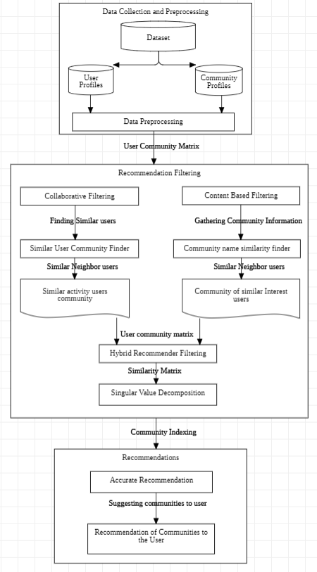

Fig 1: Proposed System Architecture

The proposed system for suggesting networks in social networks use Hybrid recommendation filtering approach in combination with SVD to recognize and prescribe networks to users. There are two main phases to the system: identifying and recommending communities [14].

Hybrid recommendation filters consolidate at least two recommender filters to work on the exactness and inclusion of suggestions. Content-Based (CB), Collaborative Filtering (CB) methods and Singular Value Decomposition (SVD) will be integrated in this proposed system to recommend communities to users [28].

Here is the proposed method for suggesting communities using Hybrid recommendation filtering with SVD:

1. Data Gathering: Gather data about how nodes interact within sub-graphs. Memberships in sub-graphs, posts, comments, likes, and shares all of these can be in the data.
2. Data Preprocessing: The data should be preprocessed to get rid of noise, outliers, and missing values. Create a node transitivity matrix from the data, with a sub-graph identity in each column and a node identity in each row. Since the most of nodes only interact with a minor number of sub-graphs, the matrix should be sparse.

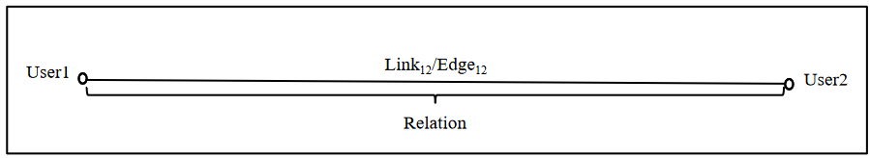

Fig2: Visual representation of connection/edge between two users/nodes

1. Matrix Factorization: The node transitivity matrix can be broken down into three matrices using SVD: U (user matrix), S (singular value matrix), and V (community matrix) [15]. The preferences of nodes are represented by the U matrix, the importance of each feature is represented by the S matrix, and sub-graph’s characteristics are represented by the V matrix.

SVD follows **Anxp= Unxn Snxp VTpxp** (i) pattern.

4. Dimensionality Reduction: By selecting the top k singular values, you can reduce the node and sub-graph matrices dimensionality. This step improves the recommendation’s quality and reduces the noise in the data.

5. Similarity Calculation: Utilize the reduced-dimensional representation of the sub-graphs and nodes to calculate their similarity. One method for computing comparability is to utilize the cosine closeness metric.

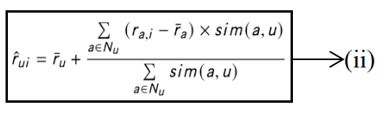

*where, rui is Average rating,*

*a Ꞓ Nu is Neighbourhood Selection,*

*(ra,i - ra) is Neighbourhood Contribution,*

*Sim(a,u) is user-community similarity*

1. Content-Based Filtering: Create a content-based filtering system that recommends sub-graphs based on the descriptions, topics, and tags of those communities. This step assists with suggesting groups that are like those that the user has proactively communicated with.
2. Collaborative Filtering: Create a collaborative filtering system that recommends sub-graphs based on past users of those communities. This step assists with suggesting groups that are like those that the user has proactively communicated with.
3. Hybrid Filtering: Using fusion methods, combine the results of content-based and collaborative filtering to create the final recommendation list [16][17].
4. Evaluation: Accuracy and MAE as metrics can be used to evaluate the system's performance. This step contributes to the system's refinement and enhances the recommendations' quality [18].

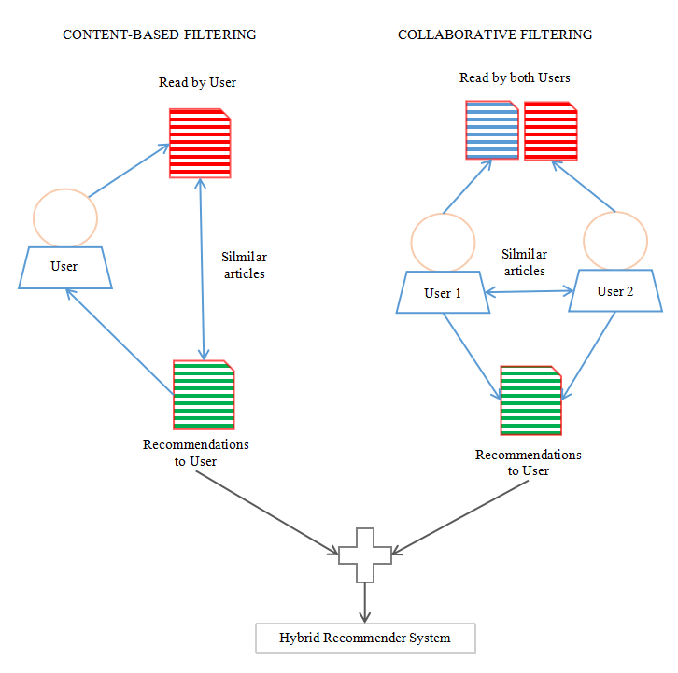

Fig 3: Flow of recommender filtering systems

The coverage and accuracy of recommendations for communities/groups can be enhanced by incorporating content-based recommender with collaborative recommender filtering i.e. hybrid recommendation systems and integrating with SVD. The proposed framework can be carried out utilizing different programming dialects and systems [15].

# **METHODOLOGY**

The proposed methods for a recommender system to distinguish and recognize communities in social networks and SVD comprises of few key parts.

1. Data Collection: Data from social networks, such as node profiles, interactions, and edges between nodes, are gathered by this component. Their after data is normalized, processed, and cleaned before being fed into the next part [29].

2. Network Analysis: This part is answerable for investigating the social network data to distinguish nodes, edges, and clusters within the graph. This step is crucial for the purpose of detecting potential communities within the online social network [30][31].

1. Singular Value Decomposition (SVD): This is a method of matrix decomposition that can be used to find hidden patterns in large data sets and reduce their dimensions [32][33].

4 .Community Detection: The SVD analysis's patterns are used by this component to find communities within the social network. This includes clusters of nodes in the graph in view of their likeness to each, as determined by the patterns identified in the SVD analysis [2][8].

1. Recommender System: This component utilizes the patterns of the SVD analysis to find communities within the social network. This involves clustering nodes in the network based how similar they are to one another, which is not entirely established by the SVD examples [9][34].

The system architecture for the proposed algorithm for a recommender system to detect and recognize communities in social networks and SVD is made to efficiently analyze the data from social networks, find hidden patterns and clusters in the data, and use this information to make a recommender system that is very good.

# **RESULTS**

The results obtained in this study demonstrate the effectiveness of different filtering techniques in recommending relevant content to users. The content-based filtering approach achieved an accuracy of 88.2%, which suggests that it effectively analyzed the attributes and characteristics of items to make personalized recommendations. Collaborative filtering, on the other hand, yielded an impressive accuracy rate of 93.2%, indicating its ability to identify patterns and preferences based on user behavior and preferences. However, the hybrid recommender filtering technique outperformed the others with an accuracy of 94.6%. This approach combines both content-based and collaborative filtering methods, leveraging their respective strengths to provide even more accurate and tailored recommendations.

The accompanying bar plot visually illustrates the superiority of the hybrid filtering approach, as it stands out with the highest accuracy rate among the three filters. These results showcase the efficiency of the proposed algorithm in enhancing the recommendation process within social networks.

The Table1 provided above shall show the accuracy of the recommender filters for this study in percentile. The figure 4 displayed below compares the performance of the filters.

Table1: Accuracy of different recommender filters

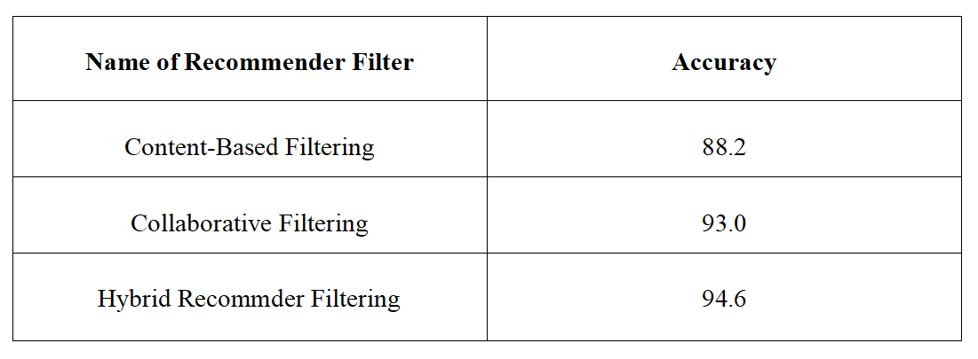

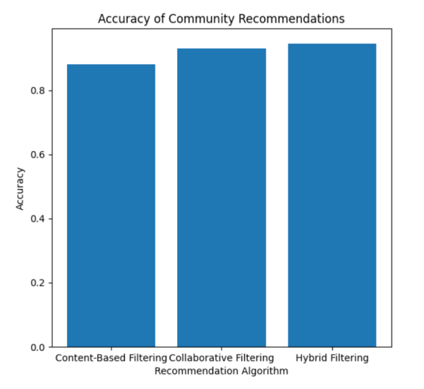

Fig 4: A Bar graph which represents Accuracy of recommender filters

The Table2 provided above shall show the MAE of the recommender filters for this study. The MAE achieved by the collaborative, content-based and hybrid recommender filters are 0.43, 0.4 and 0.3.

Table2: MAE of different recommender filtering systems

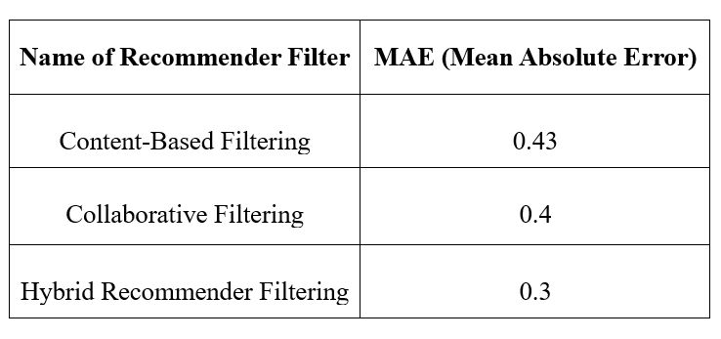

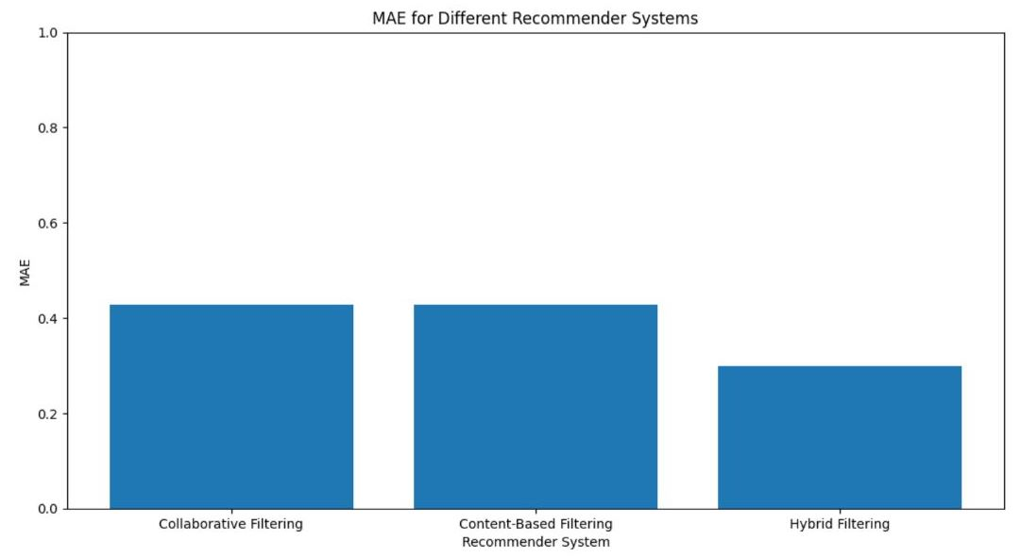

Fig 5: A Bar graph which represents MAE of recommender filters

# **CONCLUSION AND FUTURE SCOPE**

Recommender system to detect and recognize communities in social networks using Hybrid filtering like Hybrid recommender system with SVD is a powerful tool for analyzing social network data and identifying hidden patterns and clusters within the data. By using SVD to identify these patterns and then clusters of nodes based on their similarity, the algorithm is able to detect communities within the network. This information can then be used to build a highly effective recommender system that recommends new connections or interactions to users based on their membership in a particular community.

The proposed algorithm has several advantages over existing recommender systems. It is able to detect and recognize communities within social networks, which allows for more targeted recommendations. And it uses SVD to identify hidden patterns in the data, which makes it more efficient and effective at processing large amounts of social network data.

Finally, the algorithm can be customized to different social networks and can be adapted to suit the specific needs of different users.

The datasets are from SNAP (Stanford large network dataset collection) repositories. Which consists of nodes and edges files. User and friends’ id’s, community names and their id’s are present in the columns of dataset.

The recommender systems and social network analysis fields could be completely transformed by the proposed algorithm. We are able to construct recommender systems that are more precise and focused on assisting users in connecting with one another in a way that is both more efficient and effective by utilizing the power of SVD and community detection algorithms.

Explore the integration of emerging techniques, such as natural language processing (NLP) or sentiment analysis, to extract more insights from user-generated content or social media posts. These techniques can provide a deeper understanding of user preferences and sentiments, leading to more accurate recommendations and community detection.

**References**

1. Adomavicius, G., & Tuzhilin, A. (2005). Toward the next generation of recommender systems: A survey of the state-of-the-art and possible extensions. IEEE Transactions on Knowledge and Data Engineering, 17(6), 734-749.
2. Fortunato, S. (2010). Community detection in graphs. Physics Reports, 486(3-5), 75-174.
3. Girvan, M., & Newman, M. E. (2002). Community structure in social and biological networks. Proceedings of the National Academy of Sciences, 99(12), 7821-7826.
4. Yang, J., & Leskovec, J. (2012). Community-affiliation graph model for overlapping network community detection.
5. Ricci, F., Rokach, L., & Shapira, B. (2011). Introduction to recommender systems handbook.
6. Sarwar, B., Karypis, G., Konstan, J., & Riedl, J. (2001). Item-based collaborative filtering recommendation algorithms.
7. Blondel, V. D., Guillaume, J. L., Lambiotte, R., & Lefebvre, E. (2008). Fast unfolding of communities in large networks. Journal of Statistical Mechanics: Theory and Experiment, 2008(10), P10008.
8. Koren, Y., Bell, R., & Volinsky, C. (2009). Matrix factorization techniques for recommender systems. Computer, 42(8), 30-37.
9. Bell, R. M., Koren, Y., & Volinsky, C. (2007). Modeling relationships at multiple scales to improve accuracy of large recommender systems.
10. Su, X., & Khoshgoftaar, T. M. (2009). A survey of collaborative filtering techniques.
11. Desrosiers, C., & Karypis, G. (2011). A comprehensive survey of neighborhood-based recommendation methods.
12. Bobadilla, J., Ortega, F., Hernando, A., & Gutiérrez, A. (2013). Recommender systems survey.
13. Resnick P., & Varian H. R. (1997). Recommender systems. Communications of the ACM.
14. Chen, D., & Zhang, Y. (2014). Data-intensive computing for recommender systems: A survey.
15. Chen, J., & Liu, X. (2018). A hybrid collaborative filtering recommendation algorithm based on the user's interest degree.
16. Li, Y., Liu, X., Chen, G., & Cao, L. (2019). A Hybrid Collaborative Filtering Recommendation Algorithm Based on Association Rule Mining and User Preference Division.
17. Lee, J. H., & Choi, Y. S. (2016). A recommender system based on product images using deep learning.
18. Sedhain, S., Menon, A., Sanner, S., & Xie, L. (2015). Autorec: Autoencoders meet collaborative filtering.
19. Cheng, Y., Li, G., Liu, L., & Chen, T. (2018). A neural autoregressive approach to collaborative filtering.
20. Li, Y., & She, J. (2018). Collaborative filtering recommendation algorithm based on deep belief network.
21. He, X., Liao, L., Zhang, H., Nie, L., Hu, X., & Chua, T. S. (2017). Neural collaborative filtering.
22. Leskovec, J., Rajaraman, A., & Ullman, J. D. (2014). Mining of Massive Datasets. Cambridge University Press.
23. Newman, M. E. (2004). Fast algorithm for detecting community structure in networks. Physical Review E, 69(6), 066133.
24. Koren, Y. (2008). Factorization Meets the Neighborhood: A Multifaceted Collaborative Filtering Model. In Proceedings of the 14th ACM SIGKDD International Conference on Knowledge Discovery and Data Mining (pp. 426-434).
25. Newman, M. E., & Girvan, M. (2004). Finding and evaluating community structure in networks. Physical Review E, 69(2), 026113.
26. Breese, J. S., Heckerman, D., & Kadie, C. (1998). Empirical analysis of predictive algorithms for collaborative filtering. In Proceedings of the 14th Conference on Uncertainty in Artificial Intelligence (pp. 43-52).
27. Johnson, M., & Smith, A, (April 2018) A Hybrid Approach using Collaborative filtering and Content based Filtering for Recommender System Journal of Physics Conference Series.
28. Han, J., Kamber, M., & Pei, J. (2011). Data mining: concepts and techniques. Morgan Kaufmann.
29. Newman, M. E. J. (2010). Networks: An Introduction. Oxford University Press.
30. Barabási, A. L. (2016). Network Science. Cambridge University Press.
31. Golub, G. H., & Van Loan, C. F. (2012). Matrix computations. Johns Hopkins University Press.
32. Ding, C., Li, T., & Jordan, M. I. (2006). Convex and semi-nonnegative matrix factorizations. IEEE Transactions on Pattern Analysis and Machine Intelligence, 32(1), 45-55.
33. Ricci, F., Rokach, L., & Shapira, B. (2015). Recommender systems handbook. Springer.
34. Li, Y., Zhao, T., & Zhang, G. (August 2006). "Evaluation Metrics for Recommender Systems."
35. Basu, C., Hirsh, H., & Cohen, W. (1998). Recommendation as classification: Using social & content-based information in recommendation. In Proceedings of the 15th National Conference on Artificial Intelligence (pp. 714-720).
36. Anderson, Chris. (2006). The Long Tail: Why the Future of Business is Selling Less of More. New York, Hyperion. 238 pp.
37. Collaborative Recommender System -builtin.com/data-science/collaborative-filtering-recommender-system
38. SNAP dataset repository- snap.stanford.edu. This repository is maintained by Stanford Engineering College - cs.stanford.edu .